User Manual

for

DAV - Voice-Assisted Design in FreeCAD


Table of Contents
Start Page 3
Voice Assistant Window 4
Folder management menu 4
Edit Management Menu 5
Print Management Menu 5
Screenshot 5
Document Management 6
Preferences Menu 6
Information Window 7
Responsibilities 8
System Requirements 8

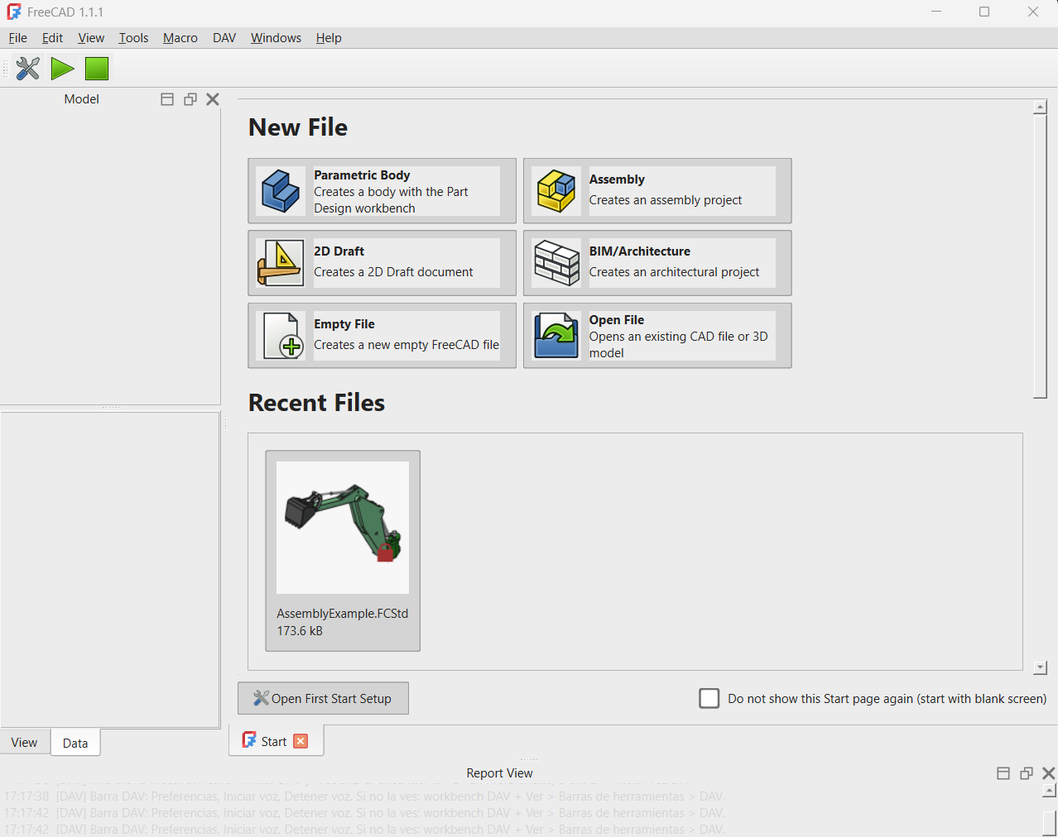
Start Page
This is the FreeCAD start page. To activate the voice-command functionality, click the green Start button in the top-left corner. To stop voice recording, click the green Stop button (green square) to the right of the Start button.

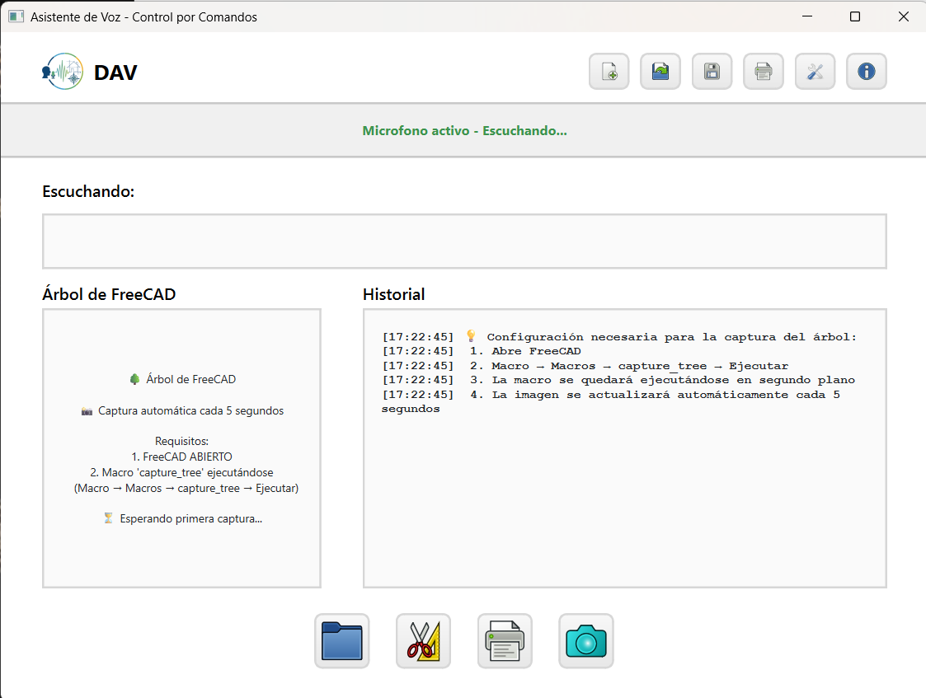
Voice Assistant Window

After clicking the Start button, the Voice Assistant window opens. It continuously transcribes your speech and provides four options at the bottom and six options in the top-right corner. Each of these options is described in the following sections.

Folder management menu

Click the Folder icon to open the file management menu.
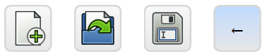
4
3
2
1

- Click this icon to create a new FreeCAD file.
- Click this icon to open an existing FreeCAD file.
- Click this icon to save the current FreeCAD file.
- Click this icon to go back.


Edit Management Menu

Click the Edit icon to open the edit management menu.
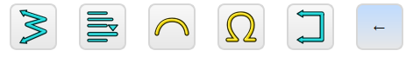
1
6
5
4
3
2

- Undo: Click this icon to reverse the last action performed.
- Redo: Click this icon to reapply the last action that was undone using the Undo command.
- Copy: Click this to copy the selected item to the clipboard without removing it from its original location.
- Cut: Click this icon to remove the selected item from its current location and copy it to the clipboard.
- Paste: Click this icon to insert the content currently stored in the clipboard at the selected location.
- Click this icon to go back.

Print Management Menu

Click the Print icon to open the Print management menu.
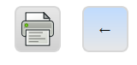
2
1

- Click the print icon to print the desired content.
- Click this icon to go back.

Screenshot

Click the Screenshot icon to take a screenshot of the screen.

Document Management
In the top-right corner you have these six options:

5
4
3
2
6
1

- Click this icon to create a new document.
- Click this icon to open a document previously created.
- Click this icon to save the document currently open.
- Click this icon to print the document currently open or if you desired a document previously save it.
- Click this icon to open the Preferences menu management. When you click this a window goes to open it.
- Click this icon to see the Information window with the command’s voices available.

Preferences Menu
This is the windows of preferences menu.
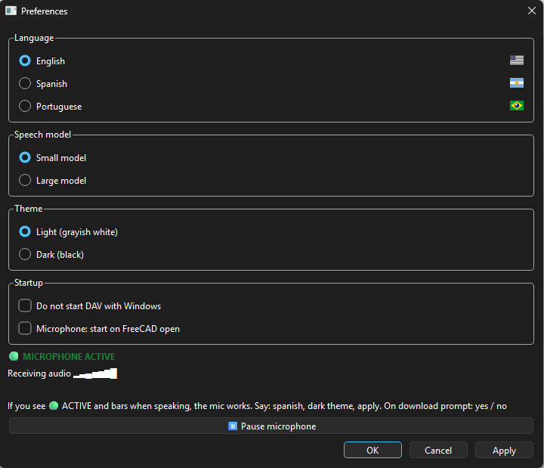
2
4
3
1

- As a first option, you can select your preferred language (English, Spanish or Portuguese).
- In the Speech model section you can select between the Small Model or Large Model. The small one is the default Speech Model so if you want to change it, you must download the Large Model.
- In the Theme options can select the Light theme or Dark light of the background window.
- The Startup options have the option for DAV that does not start when you initialize the computer and the option to activate the microphone when FreeCAD is open.

To apply the changes that you done click on Apply in the bottom right corner and then touch OK.

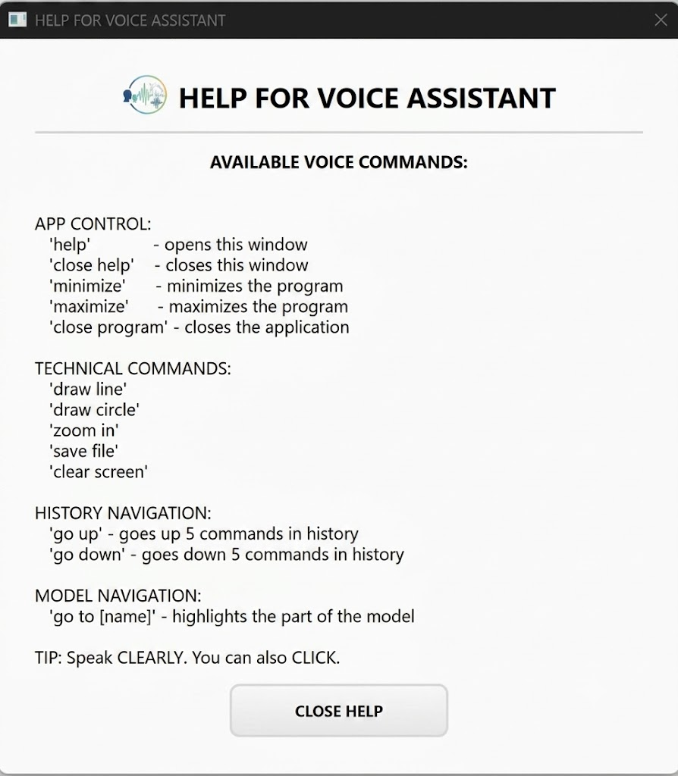
Information Window

Responsibilities
A widget that lives inside FreeCAD as a QDockWidget. It displays the navigation context, command history, and the document object tree.
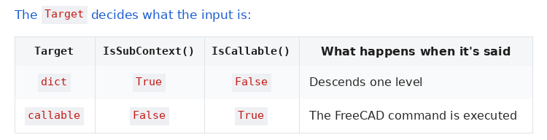
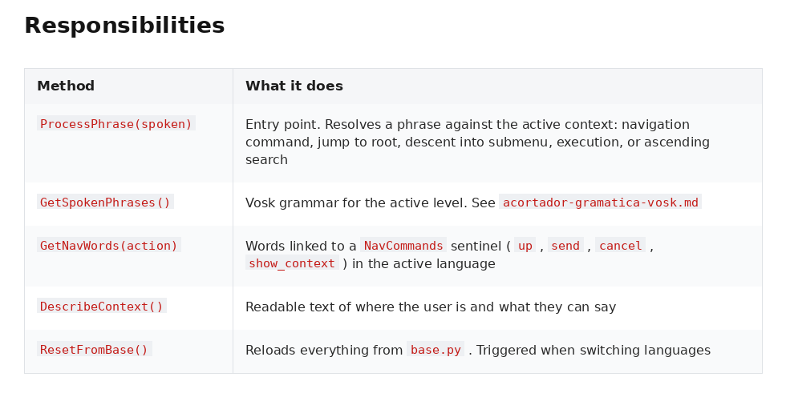
It is lenient but not infallible. Since it relies on text parsing rather than an AST, unusual formats might slip through. If a dictionary doesn't show up where it should, check first that it uses one of the two supported formats.

System Requirements
- Operating System: Windows (7, 8, 10, or 11), macOS (10.11 or later), or Linux (modern distributions).
- Processor (CPU): 64-bit processor. A multi-core CPU is recommended, with priority given to strong single-core performance, as the main geometric engine performs single-threaded calculations.
- Memory (RAM): Minimum of 6 GB. 8 GB or more is recommended (16–32 GB for large assemblies and advanced architectural projects).
- Graphics Card: OpenGL-compatible GPU. A dedicated graphics card with hardware acceleration is recommended for smooth 3D rendering.
- Storage: A few gigabytes of free disk space for installation and working cache.

